MODEL ORDINANCE FOR THE KEEPING OF HONEY BEES IN PENNSYLVANIA MUNICIPALITIES

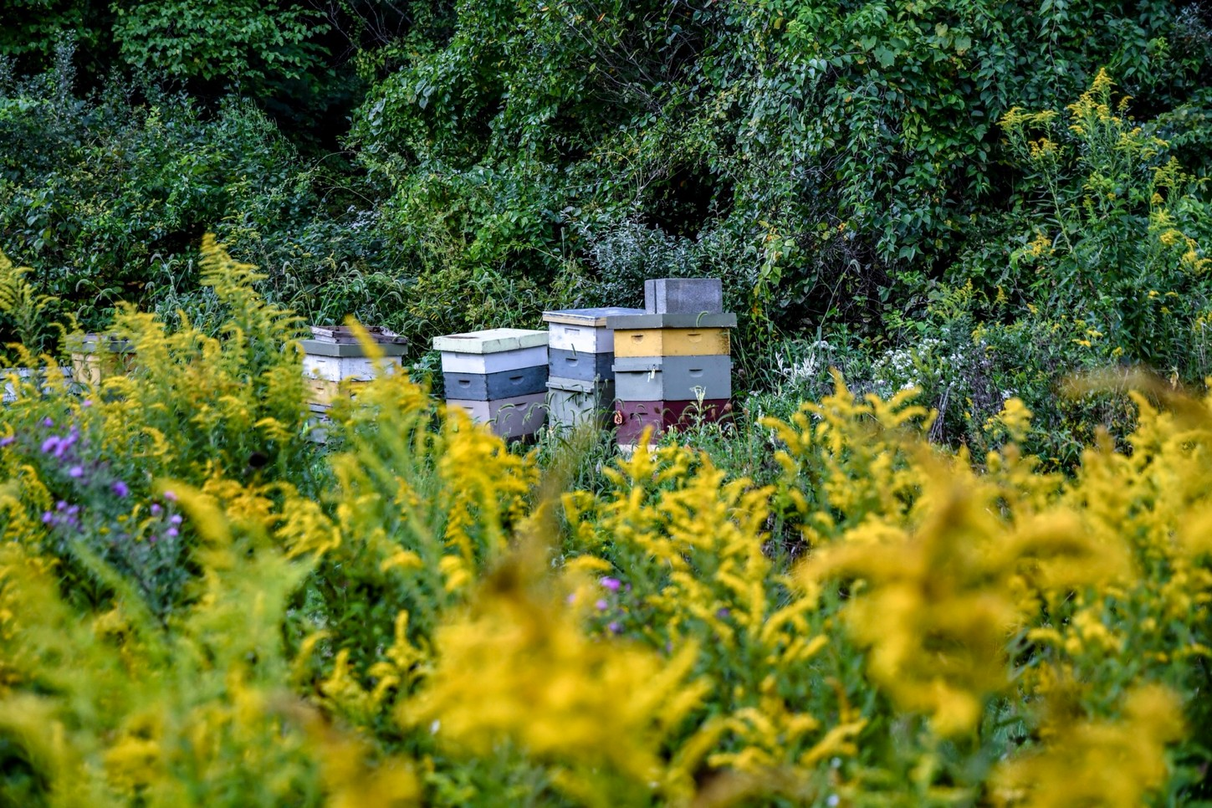
In joint consultation, the PA State Beekeepers Association, the Penn State Center for Pollinator Research and the PA Apiary Advisory Board have developed and endorsed this Model Ordinance for Beekeeping in Pennsylvania Municipalities
NOTE: This model ordinance for beekeeping provides a framework for regulating beekeeping and should only be adopted after a legal review by the municipality. Like any model ordinance, it should be reconciled with all existing ordinances that are affected by its adoption as well as tailored to an individual community’s needs and concerns. This ordinance has been adopted in several municipalities and it is encouraged to seek guidance from the participating organizations for further information and assistance.

Please contact the Pennsylvania State Beekeepers Association (PSBA) with any questions or concerns. The PSBA is available and willing to attend meetings and hearings to work with municipalities in creating an ideal ordinance for their community based on this model ordinance.

Please keep in mind that the Right to Farm Act and the ACRE Law may have some influence on what can or cannot be enacted and/or enforced.

MODEL ORDINANCE LANGUAGE/FRAMEWORK

Section 1. Intent
It is recognized that Honey bees are beneficial to humankind and to Pennsylvania in particular by providing both home garden and agricultural pollination services as well as furnishing honey, beeswax, and other useful products.
The purpose of this ordinance is to establish certain requirements for beekeeping within residentially zoned municipality.

Section 2. Definitions
As used in this article, the following words and terms shall have the meanings ascribed in this section unless the context of their usage clearly indicates another meaning:

APIARY
Any place where one or more colonies of bees are kept at a single location.

AFRICANIZED HONEY BEE
Hybrids of the African Honey bee (Apis mellifera scutellata) with various European Honey bees that are aggressive compared to the European subspecies.

BEEKEEPER
A person who owns or has charge of one or more colonies of honey bees.

BEE
Any stage of the honey bee (Apis mellifera)

BEE DISEASE
Disease such as American Foulbrood or other actionable disease as determined by the Department of Agriculture

COLONY
An aggregate of honey bees consisting of workers, drones and a queen

HIVE
A receptacle or container, that includes modern moveable frames or combs, in which an active colony inhabits and exceeds a volume volume of 50 liters (i.e. a single standard Langstroth 9 5/8” deep body with 10 frames plus one additional hive body).

DEPARTMENT
Refers to the Pennsylvania Department of Agriculture, Bureau of Plant Industry

NUCLEUS COLONY
A hive that does not exceed the volume of 50 Liters (i.e. a single 10 frame standard 9 5/8” deep body or less)

HONEY BEE
All life stages, of the common domestic honeybee, Apis mellifera species (“European” honey bee).

FLYWAY BARRIER
A wall, fence, vegetation, hedge or combination thereof that forces bees to fly at a higher elevation above ground level over the property lines in the vicinity of the apiary.

Section 3. Standards of Practice
Honey bee apiaries are permitted [by right, by conditional use, by special exception] as an accessory use in [list residential zones] when in compliance with the Pennsylvania Bee Law (3 Pa.C.S.A. § 2101 et seq., as amended) and subject to the following regulations:

Registration, Certification and Permits
    - No beekeepers may own or maintain an apiary within the municipality without first registering and maintaining a current permit for all apiaries with the Department as required by the Pennsylvania Bee Law, 3 Pa. C.S.A. § 2101 et seq., as amended.
    - A beekeeper owning or maintaining an apiary in the municipality shall promptly notify the Code Enforcement Officer or appropriate office without unnecessary delay, and in no event longer than 72 hours, if the Department revokes said apiary registration or if said registration has lapsed.
    - No beekeeper shall own or maintain an apiary within the municipality without first obtaining a registration permit from the municipality. An application for a one time registration permit shall be made in writing and upon supplied form or in such format as established by the municipality. The application shall be accompanied by a lot plan that includes the size of the lot, the location and number of hives, the location of the water source, the distance of the hives from any property lines, and, if required, the location of any flyway barriers. The issuance of a permit shall not obviate the necessity for compliance with all other municipal ordinances.

NOTE: No permit or fee is recommended, however, if a permit is required it is suggested that there be no fee or the fee does not exceed the amount or terms of the Department’s Apiary registration fee.
    - The application for a municipal permit shall also be accompanied by written evidence that the applicant has completed a beekeeping educational course/program with a minimum of 8 hours of instructions or has a letter of validation from an officer of the PA State Beekeepers Association, an officer of a local bee club or a certified Master Beekeeper.

NOTE: there are no “certified” beekeeping classes
    - Beekeepers that wish to own or maintain an apiary on property that they do not own must include written permission from the property owner or landlord that explicitly indicates that the beekeeper has permission to own or maintain an apiary on the subject property. Such written permission shall be supplied to the municipality as part of the beekeeping registration application.

Section 4. Location and Colony Density
Placement of an apiary on a residential property should conform to the following regulations so as to minimize and eliminate any possible concerns to adjoining neighbors:

Hive Location and Density
    - Location of hives must comply with the following criteria:
      - Hives shall not be located within 10 feet of any side or rear property line unless a flyway barrier is in place or the hive(s) are located at least 10 feet above grade
      - Hives shall not be located within a front yard.
      - Hives shall not be located within 50 feet of a pre-existing swimming pool or a pre-existing kenneled animal.
      - Apiaries are not permitted within 10 feet any buildings located on adjacent properties.

Maximum Number of Hives.
    - For a property with a minimum of 2,000 square feet of lot area, a beekeeper is permitted to keep two hives. For each additional 2,000 square feet of lot area, the beekeeper is permitted two additional hives.

Exceptions:
A beekeeper may exceed these regulations under the following conditions:
        - As part of normal honey bee colony management, a beekeeper may also keep, in addition to allowable standard hives, for up to 45 days between April 15 and August 15th, two nucleus colonies per standard hive, provided they are used for managing colony strength, to minimize reproductive swarming, queen rearing or swarm capture.
        - For each allowed hive, a single nucleus hive may be kept from August 16th to April 14th to allow a beekeeper to mitigate winter bee losses
        - Apiaries that are pre-existing prior to enactment of this ordinance shall not be subject to the limitations of section 4b and shall not exceed the number of hives active at the tine of the ordinance and shall be confirmed by the pre-existing apiary registration of the location as reported by the Department.

Hive Density
    - Consider reasonable hive densities for given locations. Factors influencing hive density in an area may include: human density, quality and quantity of plants, and number of bee hives already present. Beekeepers and educational venues with a beekeeping component may have varying numbers of colonies in an area depending on many factors including: normal agricultural operations, pollination and other contractual requirements, queen bee and/or nucleus colony production, honey production and educational needs.
    - The PA Apiary Advisory Board strongly recommends seeking expert advice from the Pennsylvania State Beekeepers Association, The Penn State Center for Pollination Research, The Pennsylvania Department of Agriculture, local beekeeping associations, universities and colleges with an apiary program in order to determine optimal hive densities. The Pennsylvania Pollinator Protection Plan is also a great resource and can be found at:

https://ento.psu.edu/pollinators/pollin-spotlight-items/the- pennsylvania-pollinator-protection-plan-p4

- Section 5. Zoning
Apiaries may be located in any zoning district.

Hive Type, Orientation and Maintenance
    - All beekeepers shall comply with rules and regulations set forth by the Pennsylvania Bee Law, 3 Pa. C.S.A. § 2101 et seq., as amended
    - All beekeepers, shall, to the best of their ability, maintain their colonies per the Voluntary Best Management Practices for Maintaining European Honey Bee Colonies in the Commonwealth of Pennsylvania as provided and amended by the Pennsylvania Apiary Advisory Board.
    - To the extent possible, hive entrances shall face away from the closest neighboring property and in such a direction that the bees fly across the beekeeper’s property at sufficient distance to gain a height of at least the six feet at the property line. The use of barriers may be employed to redirect the bees flight pathway and establish bee flight pathways above six feet. Should the flight path not be able to be obtained as described above, then a “flyway barrier” shall be placed at least six feet in height, shall be placed along side of the hive(s) that contains the entrance to the hive(s), shall be located within five feet of the hive(s) and shall extend at least two feet on either side of the hive(s). A “flyway barrier” shall consist of a fence, vegetation, hedge, or a combination thereof. No flyway barrier is required for hive(s) that are located greater than 10 feet from property lines or on porches, balconies or roof tops that are at least 10 feet above grade except on adjacent properties where such porch, balcony or roof is located less than 10 feet from a property line.

Exceptions to Flyway Barrier
        - A flyway barrier is not required if the property adjoining the apiary lot line is:
          - Undeveloped, or
          - Zoned agricultural, industrial or is outside municipal limits, or
          - Is a state game lands, state park, national forest, state forest, natural park, or conservation area and has no pre- existing human or horse trails located within 25 of the property line.

    - A supply of fresh water shall be maintained in a location readily accessible to all bee colonies on the site throughout the day to prevent bees from congregating at neighboring swimming pools or other sources of water on nearby properties between April 1- Nov 1
    - All beekeepers shall ensure that no bee comb or other materials that attract honey bees are left upon the ground of the apiary site. Upon removal from the apiary, all such materials shall be properly maintained in a sealed container or placed within a building or other bee proof enclosure, so long as bees are kept on the property.

Section 6. Inspection

If an inspection is required as a result of a nuisance complaint, the designated municipal code enforcement officer will inspect the property only and not the bee hives. It is recommended that the state or local beekeeping organization be contacted to assist in understanding how the complaint arose and to what extent it is actually caused by the honey bees/beekeeper (i.e “bee” stings are often caused by yellow jackets, hornets and wasps and mistakenly blamed on honey bees because the honey bee colonies can be seen unlike many other aggressive stinging insects). A notice of 48 hours shall be given to the beekeeper prior to any inspection.

Section 7. Nuisance
It shall be unlawful for any beekeeper to keep any hive in such a manner as to cause any unhealthy condition or purposefully interfere with the normal use of adjoining properties. By way of example and not limited to, the following activities are herby declared a nuisance and therefore unlawful:
  - The use of receptacles for honey bees that does not comply with the Pennsylvania Bee Law, 3 Pa. C.S.A. § 2101 et seq., as amended
  - Hive placement and related bee movement such that the bees, without provocation, interfere with the reasonable freedom of movement of persons in a public right-of-way, or the location of bees have a proven impact to the general safety, health, and welfare of the general public.

SECTIONS OF EXISTING ZONING ORDINANCES THAT NEED TO BE REVISED

27-302 – Ag District
1.A – Permitted Uses

27-402 -- Rural Residential Zoning District
10.B – (Non-Intensive Animal Husbandry - Upon Approval of the ZHB a 5-acre minimum

27-502 – R1 Zoning District
H(1) and (2) (Upon approval of the ZHB a 10-acre minimum)

=====================================================================
This model ordinance is the result of proven beekeeping practices in Pennsylvania with hives in dense urban areas such as Pittsburgh and Philadelphia to the rural counties of central and northern Pennsylvania. These ordinances as written allow for beekeeping for the majority of residents who desire to pursue this rewarding hobby.
85% of all beekeepers in Pennsylvania maintain less than 10 colonies on their property. The PA Apiary Advisory Board strongly recommends seeking expert advice from the
Pennsylvania State Beekeepers Association, The Penn State Center for Pollination Research, The Pennsylvania Department of Agriculture, local beekeeping associations, universities and colleges with an apiary program in order to determine optimal hive densities. The Pennsylvania Pollinator Protection Plan is also a great resource and can be found at:

https://ento.psu.edu/pollinators/pollin-spotlight-items/the- pennsylvania-pollinator-protection-plan-p4

Important Links:

PA State Beekeepers Association
www.pastatebeekeepers.org

PA Department of Agriculture. Bureau of Plant Industry https://www.agriculture.pa.gov/Plants_Land_Water/PlantIndustry/Entomology/Apiary/Pages/de fault.aspx

PA Pollinator Protection Plan
https://ento.psu.edu/pollinators/pollin-spotlight-items/the-pennsylvania-pollinator-protection- plan-p4

Penn State Center for Pollinator Research
https://ento.psu.edu/pollinators

